+12 volts and ground from battery pack

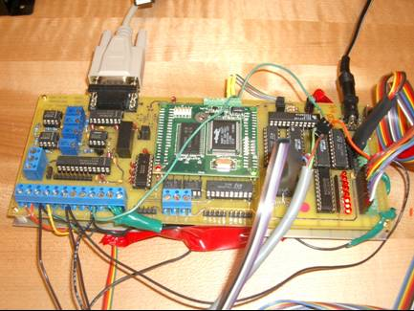
Port E, Pins 6,7 were used (Output pins), the 3rd wire is a ground.
The digital encoders, both were used for the Tilt and Oarlock location. There are 5 pins for each connection but pin #4 is not needed because only used location of encoder, not counting full revolutions. The other wires were a ground wire, +5 volt, and two pulse wires which determine the present location of the encoder.
These are the Analog to Digital pins, only two were needed for the final project. The first was used for the IR sensor voltage output and the second was used for the Strain gage output voltage. The other two were connected to the accelerometers but are not needed. The black wires were all connected to ground.
Digital Inputs, 8 connections plus ground
5 were used, 4 for the keypad, 1 for the reed switch.
Digital Outputs, 8 connections plus ground
All 8 were used.
Port B, the serial port used for the RF modem.
Enclosure 14

